**Lastname, Firstname**

**CS214 – Database Technologies**

**HOP NUMBER**

**Part 1**

**SCREENSHOT x3**

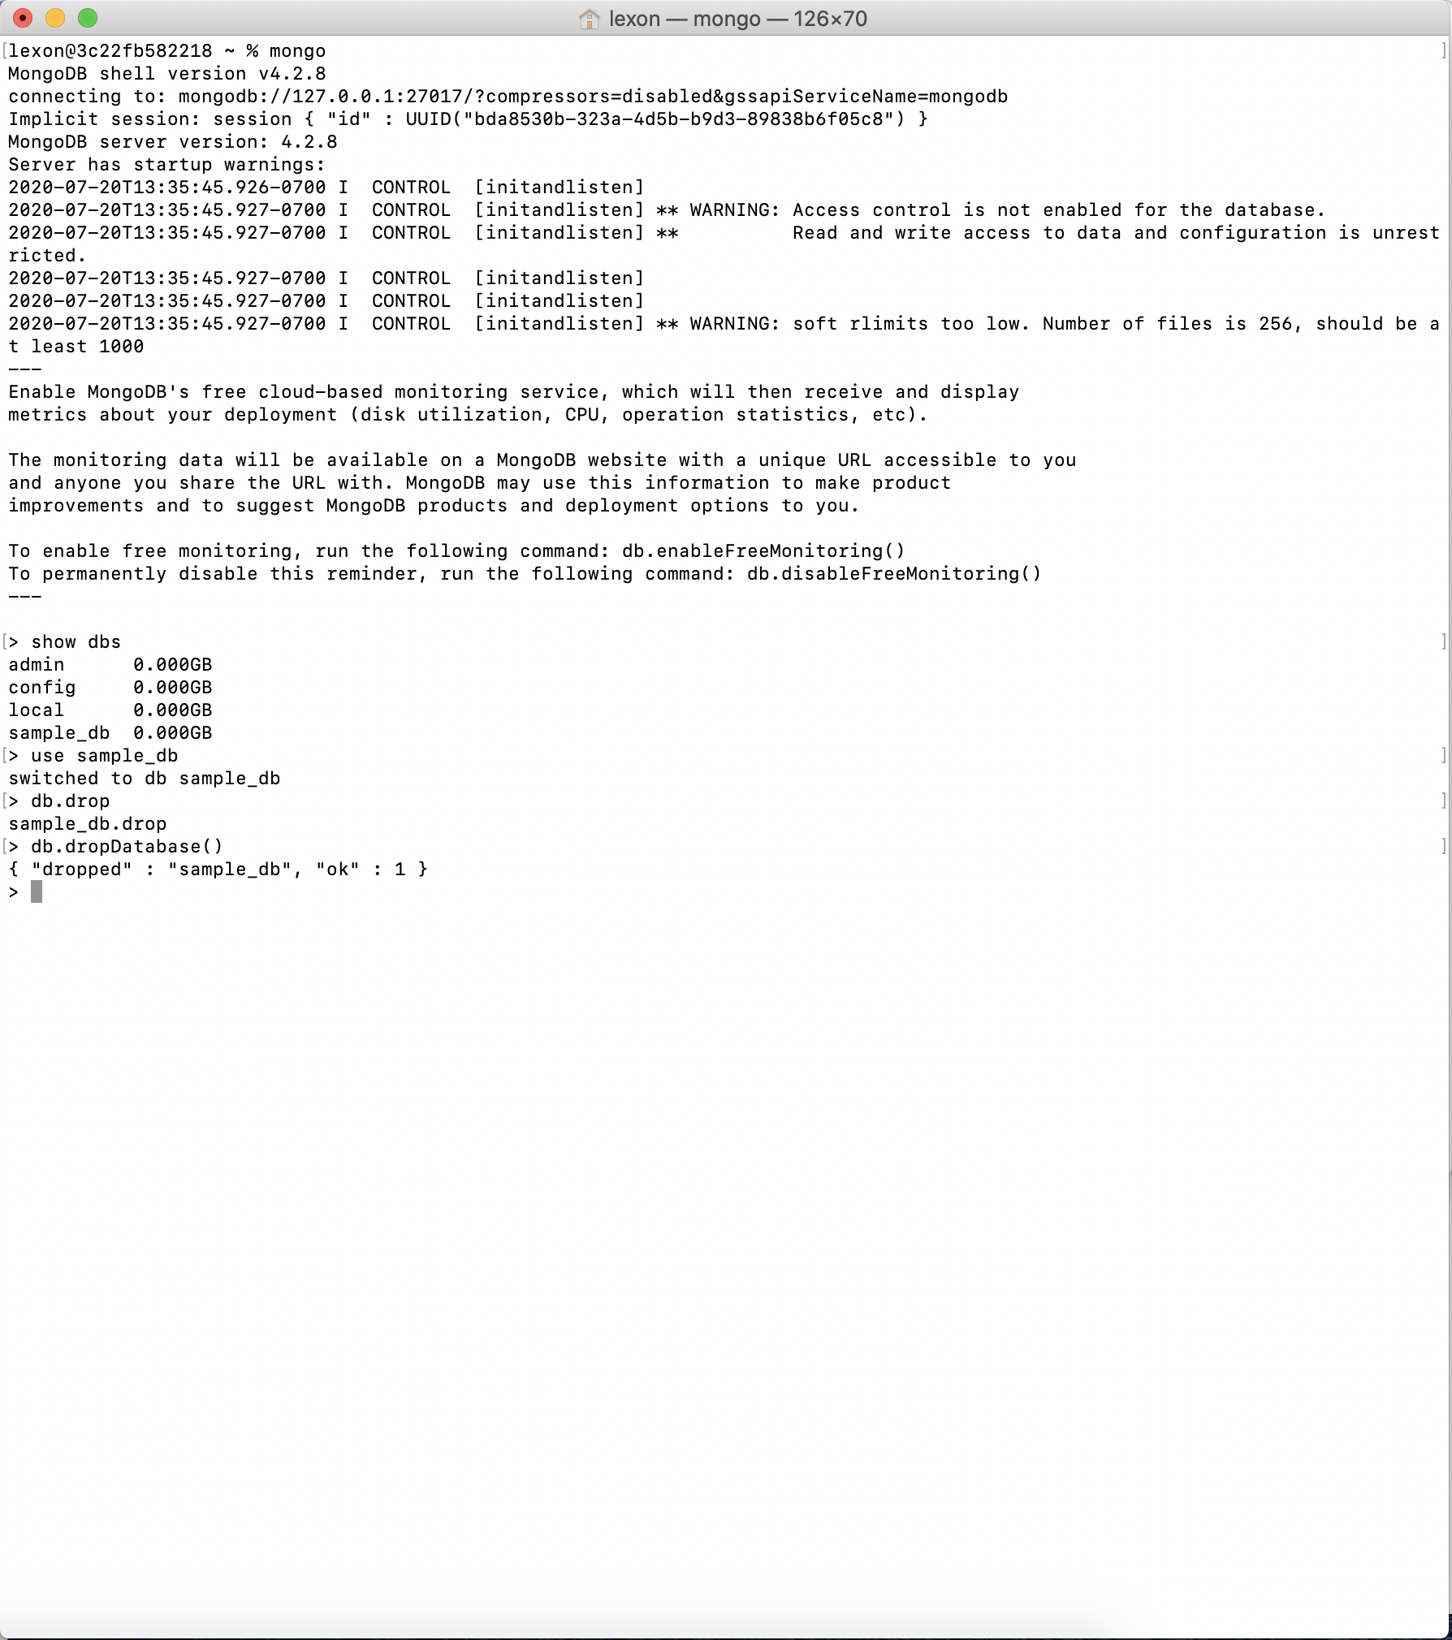

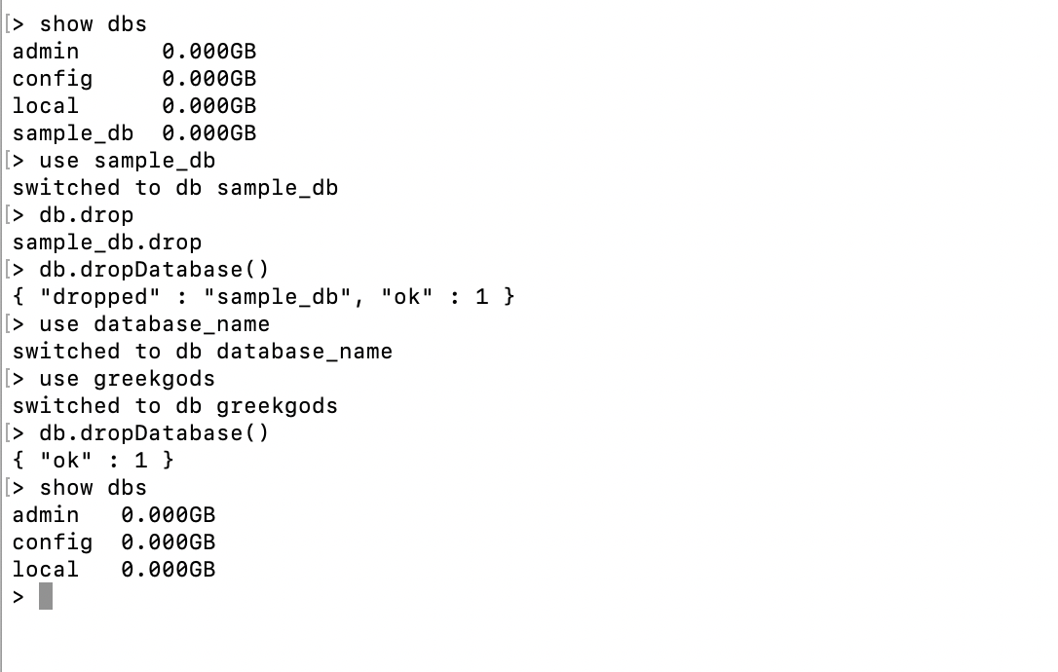

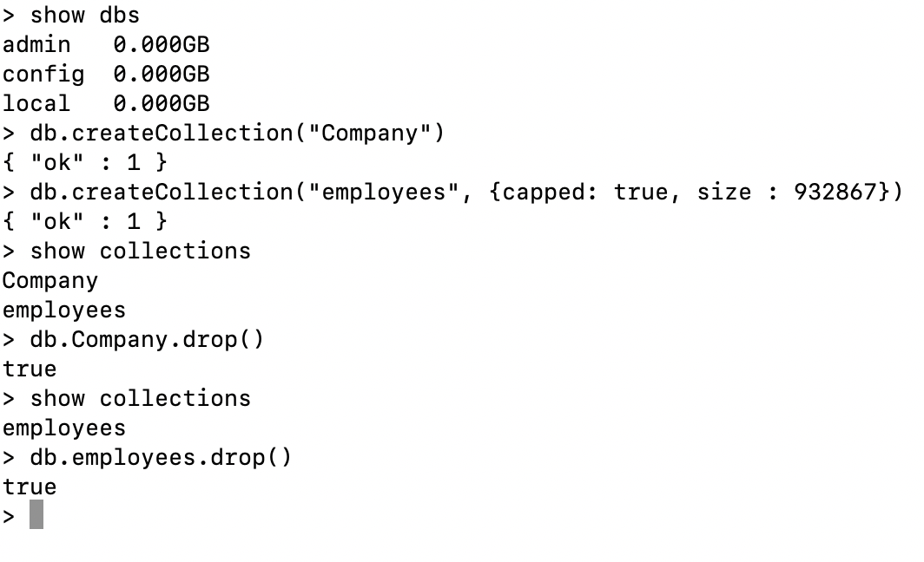

**PART 2**

This Hands on Practice talked about deleting (also known as ‘dropping’) a database as well as creating a collection in Mongo DB. For this HOP, we’ll use “sampl_db”.

From the Terminal, launch Mongo by typing:

***mongo***

The first step in deleting a database is identifying a database that needs deleting:

***show dbs***

A list of available databases will be displayed.

After identifying which database you would like to deleted one method for deletion is simply navigate to that database by typing:

***use sample_db***

Then simply type:

***db.dropDatabase()***

***show dbs***

The ‘show’ command will help you verify that the database was dropped.

Creating a collection:

The syntax for creating a collection is ***db.createCollection(name, options)*** where ‘name’ will be the name of the collection and ‘options’ will specify the parameters for the database.

As an example, the command:

***db.createCollection(“employees”, {capped: true, size: 932867})***

…will create a collection called ‘employees’ and set the size at 932867 bytes.

Similar to databases, you can delete a collection by ‘using’ that collection, then typing:

***db.employees.drop()***